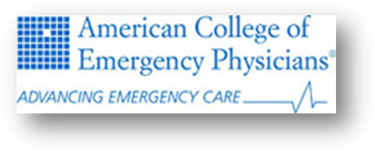
Continuing Medical Education Mission
Purpose
The American College of Emergency Physicians CME program seeks to provide its membership and other healthcare professionals with education that is vital to the quality and patient safety of the emergency patients for whom they provide emergency care. ACEP’s CME Program, therefore, goes beyond the traditional administrative and accrediting functions of medical education, and challenges itself to become a catalyst, advocate for, and a provider of education that promotes change, development and improvement.
Therefore, the purpose of the program is to provide high-quality, evidence-based educational opportunities that are designed to advance emergency personnel competence, enhance practice performance, promote patient safety, and improve patient outcomes.
Content
Unique to the environment of the practice of emergency medicine and in accordance with the Model of the Clinical Practice of Emergency Medicine (EM Model), ACEP’s CME Program covers a wide range of topics that spans all of the systems of the human body with an emphasis on special skills associated with emergency medicine including 1) an assessment of patient acuity; 2) tasks that must be performed to provide appropriate emergency medical care; and 3) skills related to conditions, symptoms, and disease presentations. Together these three components describe the clinical practice of Emergency Medicine and differentiate it from the clinical practice of other specialties. The CME curriculum of the College draws from this educational paradigm in all of its educational activities.
CME content is based on gaps in professional practice as determined through needs assessments conducted as a fundamental part of CME activity planning. The EM Model—developed by the ACEP in collaboration with the American Board of Emergency Medicine (ABEM) and the Society for Academic Emergency Medicine (SAEM)—defines the scope of practice of emergency medicine and serves as a key resource in the gap analysis process.
Target Audience
The College’s audience is its membership and other healthcare professionals who face emergency situations. There are more than 27,000 potential member learners for whom the College’s CME Program provides lifelong learning that seeks to improve competence, performance-in-practice, and/or the improvement of outcomes for emergency patients.
Types of Activities
ACEP’s educational activities are provided in a number of venues and formats:
- ACEP’s annual Scientific Assembly

- Other workshops and conferences throughout the year

- Various enduring material formats including print, electronic, and web-based learning

- ACEP Chapter meetings and enduring materials
CME activities at ACEP are designed to promote change and improvement. Various learning technologies are used to expand on and reinforce education delivered via face to face meetings.
Expected Results
Each CME activity provided by the College has an intended outcome as indicated in the early planning process. The CME Program seeks to improve one or more of the following outcomes of education as indicated below:
- For Improvement in Competence—The College measures the learner’s ability to apply knowledge learned through practice strategies using case studies and other measurements at the conclusion of the activity.

- For Improvement in Performance—The College measures the learner’s ability to apply learning goals in practice as determined by follow-up questionnaires administered 2-4 months post-activity and hands-on procedure labs used to demonstrate skills.

- For Improvement in Patient Outcomes—The College asks learners to report observations of patient outcomes related to key learning objectives when performance improvement questions are asked (2-4 months post-activity).
The results of educational outcomes measurements are analyzed by both staff and members of the Education Committee, and improvements to the program that are indicated are designed and executed on an ongoing basis.

Approvals:
The ACEP Board of Directors, June 23, 2009

